TABLE OF CONTENTS

Abstract………………………………………………………………................ 2
Problem Definition/Objective………………………………………………. 3- 4
- Problem Definition………………………………………………........................... 3
- Objective…………………………………………………………............ 4
1.INTRODUCTION………………………………………………………… 5- 6
  - Need of RFID Door lock system using Arduino………………….. 5- 6
2.THEORY………………………………………………………………….. 7- 9
  - WORKING METHODOLOGY……………………………………... 7
  - WORKING CONCEPT OF RFID DOOR LOCK SYSTEM USING ARDUINO…………………………………………………………8- 9
3.IMPORTANT FINDINGS…………………………………………………..10
4.RESULTS AND DISCUSSIONS……………………………………….11- 12
5.CONCLUSION/FUTURE SCOPE…………………………………...…13- 14
5.1. CONCLUSION……………………………………………………...14
5.2. FUTURE SCOPE………………………………………………..13- 14
REFFERENCES……………………………………………………………….15

- Abstract: -
The RFID door lock system using Arduino is an innovative project that aims to enhance security in various applications, such as homes, offices, and industries. This system utilizes radio-frequency identification (RFID) technology to authenticate users and grant access to a secured area. The system consists of an Arduino board, an RFID reader module, a servo motor, and a few other electronic components. The RFID reader module reads the unique identification code of the RFID tag/card held by the user, and the Arduino board verifies it against a pre-registered database. If the code matches, the servo motor unlocks the door, and the user is granted access. The system is efficient, reliable, and easy to install, making it an excellent choice for security purposes.

- Problem Definition/Objective: -
- Problem Definition: -
While RFID door lock systems using Arduino offer several benefits, there are some potential problems that may arise. Here are some problem definitions related to RFID door lock systems using Arduino:
- System reliability: One potential problem with RFID door lock systems using Arduino is system reliability. If the system is not designed or programmed properly, it may malfunction, leading to access control issues.
- Security concerns: While RFID technology is relatively secure, it is not foolproof. If the encryption used to protect the system is weak, it may be vulnerable to hacking or other security breaches.
- Cost: Although RFID door lock systems using Arduino are relatively inexpensive compared to other access control systems, the cost can still be a barrier for some individuals or businesses.
- RFID reader range: The range of the RFID reader can be a problem if it is too short, or too long. A short range may require the user to hold the RFID tag or card very close to the reader, while a long range may allow unauthorized access from a distance.
- Power supply: An RFID door lock system using Arduino requires a stable and reliable power supply. If the power supply is not sufficient, the system may not function correctly.
- Compatibility issues: There may be compatibility issues between the RFID reader and the Arduino board, or between different components of the system. These issues can result in the system not functioning as expected.
- Installation and maintenance: Installation and maintenance of the system can be a problem if the user does not have the necessary technical expertise. This can result in a poorly installed or maintained system that is vulnerable to malfunction or security breaches.

- Objective: -
To develop a system that uses RFID technology to provide access control with high accuracy and reliability.
- To create a secure and tamper-proof database of authorized users, which can be updated easily as per the requirements.
- To design a system that is easy to install, user-friendly, and low maintenance.
- To ensure that the system is energy-efficient and can operate for extended periods using a battery or a power source.
- To provide an affordable and effective solution that meets the security needs of small to medium-sized applications.

- INTRODUCTION
An RFID door lock system using Arduino is a DIY electronic access control system that utilizes an Arduino microcontroller and RFID technology to create a secure and convenient entry system. The system consists of an RFID reader, an Arduino microcontroller, a locking mechanism, and RFID tags or cards. The RFID reader is connected to the Arduino, which is programmed to receive and verify the identification information from the RFID tag/card. Once the identification information is verified, the Arduino sends a signal to the locking mechanism to unlock the door.
To build an RFID door lock system using Arduino, you will need to first select an appropriate RFID reader and locking mechanism. You will also need to program the Arduino to recognize and respond to the identification information from the RFID tags/cards.
One of the benefits of using Arduino in an RFID door lock system is its flexibility and customization. With the ability to program and modify the system's behaviour, you can tailor it to your specific security needs and integrate it with other systems or devices.
Overall, an RFID door lock system using Arduino can provide a cost-effective and customizable solution for electronic access control, suitable for both personal and commercial applications.
  - Need of RFID door lock system using Arduino
- Improved Security: Traditional lock and key systems can be compromised easily, and passwords can be hacked. RFID door lock systems offer improved security by requiring a unique RFID tag for access.
- Scalability: RFID door lock systems using Arduino can be easily scaled to fit various security needs. Additional RFID tags can be programmed and added to the system as needed, making it an ideal solution for organizations with changing security requirements.
- Convenience: With RFID door lock systems, there's no need to carry around keys or remember passwords. The RFID tag can be easily carried in a wallet or attached to a keychain, making it a convenient solution for access control.
- Integration with other systems: RFID door lock systems can be integrated with other security systems, such as alarms and cameras, to provide a more comprehensive security solution.
- Business security: RFID door lock systems can be used to secure business premises, including warehouses, offices, and retail stores. By restricting access to authorized personnel only, businesses can protect their assets and prevent theft.
- Home security: An RFID door lock system can be used to secure homes and apartments, providing an additional layer of protection against intruders. Homeowners can also use the system to control access to certain areas of the home, such as a home office or storage room.

- THEORY
An RFID (Radio Frequency Identification) door lock system using Arduino is a popular project that allows you to control access to a specific area by verifying the identity of the person attempting to enter.
Here is a general overview of how the system works:
- RFID tags or cards are assigned to each person who is allowed access to the area. These tags contain a unique identifier that is read by the RFID reader.
- The RFID reader is connected to an Arduino board, which is programmed to verify the identity of the person attempting to enter.
- If the RFID tag is recognized, the Arduino board sends a signal to a servo motor, which unlocks the door. If the tag is not recognized, the door remains locked.
- The system can be configured to log access attempts and send notifications to a designated person or system.
Here are the steps to build an RFID door lock system using Arduino:
- Gather the necessary components: Arduino board, RFID reader, servo motor, RFID tags or cards.
- Connect the RFID reader to the Arduino board according to the manufacturer's instructions.
- Write the code to read the RFID tag and send a signal to the servo motor to unlock the door. You can find sample code online to help you get started.
- Test the system to ensure that it is functioning as expected.
- Mount the RFID reader and servo motor on the door, and attach the necessary wiring.
- Assign RFID tags to each person who is allowed access to the area.
- Configure the system to log access attempts and send notifications if desired.
- Test the system again to ensure that it is functioning correctl

  - WORKING METHODOLOGY
- Circuit Diagram
The circuit diagram of the door lock is shown below. In this case, we are using the SPI protocol for communication between RC522and Arduino Uno.
The 9V battery has not been shown in the Diagram but you can just connect the positive terminal to Vin and the Negative terminal to GND.
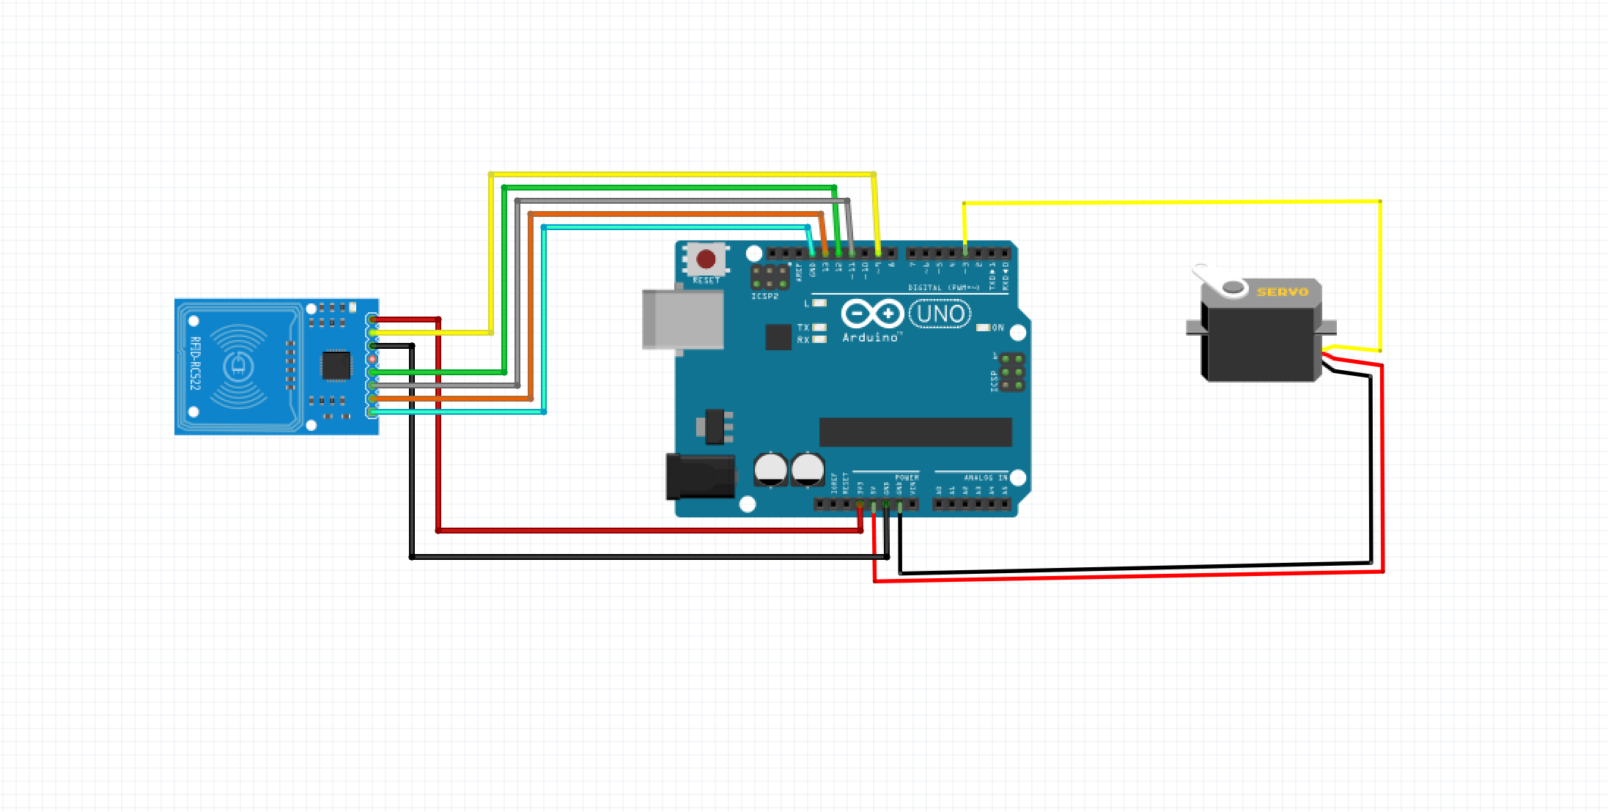
  - WORKING CONCEPT OF RFID DOOR LOCK SYSTEM USING ARDUINO: -
- At a rudimentary level, RFID systems consist of three main components: an RFID tag or smart label, an RFID reader, and an antenna. RFID tags contain an IC and an antenna, which are used to transmit data to the RFID reader (also called an interrogator). Each RFID tag has its key. So when the RFID tag has been scanned by the reader, it tries to find whether the key of the tag matches the authorized key. If the key matches, then it can be assigned a specific function. This has to be done via changes in the code in Arduino IDE.
- So once the key matches, the RFID reader sends the signal to the Arduino board. The board in turn sends another signal to the SG90 micro servo. The micro servo is attached to the door handle in such a way that whenever the servo rotates the door opens.

- IMPORTANT FINDINGS
There are several important findings related to RFID door lock systems using Arduino:
- RFID door lock systems are more secure than traditional lock and key systems because they require a physical object, such as an RFID tag or card, to grant access.
- RFID door lock systems using Arduino are relatively easy to build and program, making them accessible to individuals with limited technical experience.
- Arduino provides a versatile platform for building and customizing RFID door lock systems. With the right sensors and programming, you can create a system that suits your specific needs.
- An RFID door lock system using Arduino can be expanded to include features such as logging access attempts and sending notifications to designated persons or systems.
- RFID door lock systems using Arduino are particularly useful for small businesses, home security systems, and other scenarios where access control is required.
- While RFID technology is relatively secure, it is not foolproof. It is important to use strong encryption and take other security measures to prevent unauthorized access.
- The cost of building an RFID door lock system using Arduino is relatively low, making it an affordable option for individuals and small businesses.

- RESULTS AND DISCUSSIONS
To discuss the results and discussions of an RFID door lock system using Arduino, we need to consider the following aspects:
- System design: The design of the system plays a crucial role in its overall performance and reliability. A well-designed system should consider the specific needs and requirements of the user, as well as the environmental factors that may affect the system's operation.
- Hardware components: The hardware components used in the system, such as the RFID reader, Arduino board, power supply, and locking mechanism, should be of good quality, compatible, and reliable. The selection of these components will affect the overall performance and security of the system.
- Software programming: The software programming of the Arduino board is critical to the correct and reliable operation of the RFID door lock system. The programming should include features such as access control, authentication, logging, and notifications.
- Testing and validation: The RFID door lock system should be tested and validated before it is put into use. This includes testing the system's operation under different environmental conditions, and ensuring that it meets the user's specific requirements.
- User experience: The user experience is an important factor in the design and operation of an RFID door lock system. The system should be easy to use and intuitive, with clear instructions and feedback provided to the user.
Based on these factors, the results and discussions of an RFID door lock system using Arduino can be summarized as follows:
- The system design should take into account the specific needs and requirements of the user. The RFID door lock system using Arduino can be used in a variety of applications, including business security, home security, access control for public spaces, data centres and server rooms, and healthcare facilities.
- The hardware components used in the system should be of good quality, compatible, and reliable. The selection of these components will affect the overall performance and security of the system.
- The software programming of the Arduino board should include features such as access control, authentication, logging, and notifications. This will ensure that the system functions correctly and reliably.
- The RFID door lock system should be tested and validated before it is put into use. This includes testing the system's operation under different environmental conditions, and ensuring that it meets the user's specific requirements.
- The user experience is an important factor in the design and operation of an RFID door lock system. The system should be easy to use and intuitive, with clear instructions and feedback provided to the user.

- CONCLUSION/FUTURE SCOPE
  - CONCLUSION: -
In short, an RFID door lock system using Arduino is a secure and reliable means of access control that can be tailored to specific user needs. Proper design, hardware selection, software programming, testing, and user experience are crucial to ensuring the system functions correctly and reliably
  - FUTURE SCOPE: -
RFID door lock system using Arduino has a promising future as it provides enhanced security and convenience compared to traditional locks. With the advent of the Internet of Things (IoT), RFID door locks can be integrated with other IoT devices such as security cameras, smart lighting, and alarms to create a smart home or office environment.
In the future, we can expect RFID door lock systems to become more sophisticated and reliable with improved encryption and security protocols. We may also see the integration of biometric authentication methods such as fingerprint recognition and facial recognition, which will further enhance security and convenience.
As the technology becomes more advanced and affordable, we can expect RFID door locks to become more widespread and popular, particularly in commercial and industrial settings where security is of utmost importance. Moreover, the emergence of new wireless communication technologies such as 5G and Wi-Fi 6 will facilitate faster and more reliable communication between RFID door locks and other IoT devices.
- Improved security: As technology continues to advance, there is a constant need to improve security systems. The RFID door lock system using Arduino can be enhanced by incorporating more sophisticated encryption and authentication methods, such as biometrics or two-factor authentication, to make the system even more secure.
- Integration with smart home systems: The RFID door lock system can be integrated with other smart home devices, such as cameras, sensors, and lighting systems. This would enable homeowners to remotely monitor their homes and control access to various parts of the house.
- Expansion of functionality: The RFID door lock system can be expanded to include additional features such as time and attendance tracking, real-time monitoring, and automated notifications.
- Miniaturization and cost reduction: With advancements in technology, the components used in the RFID door lock system can become smaller and more affordable, making it more accessible to a wider audience.
- Application in industries: The RFID door lock system can be applied in industries such as healthcare, retail, logistics, and manufacturing, where tracking and control of access are essential. This can help in inventory management and employee tracking.

REFFRENCES

[1] M. R. Rieback, B. Crispo, and A. S. Tanenbaum, "The Evolution of RFID Security"; Pervasive Computing, IEEE Volume 5, Issue 1, Jan.- Mar. 2006.
[2] Snehal Jagtap, Nikita Pathak , Saragam Lavangare , Mayuri Ghanwat , Shilpa Jadhav, ‘’ RFID and Password based Door Lock System using Arduino’‘Volume 7, Issue 7, July – 2022 International Journal of Innovative Science and Research Technology ISSN No:-2456-2165
[3] Sarthak Batra , Amruta Patnaik “ RFID Smart Card Door Lock ” Vol. 10 Issue 11, November-2022 International Journal of Engineering Research & Technology (IJERT) ISSN: 2278-0181
[4] https://circuitdigest.com/article/servo-motor-working-and-basics
[5] https://en.wikipedia.org/wiki/Jumper_cable

